[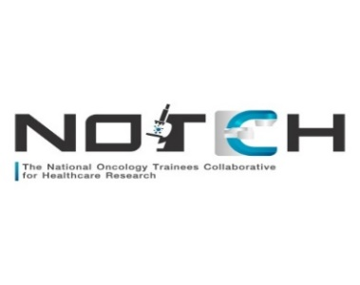](https://www.google.co.uk/url?sa=i&url=https://www.uknotch.com/&psig=AOvVaw33MVeKt95ePh-_kBmwzxcX&ust=1601366059743000&source=images&cd=vfe&ved=0CAIQjRxqFwoTCMjH2sivi-wCFQAAAAAdAAAAABAE)

**5th Annual NOTCH Research Symposium: 24th- 25th March 2025**

**Abstract submission guidance**

**Submission Deadline: Monday 24th February 2025**

The NOTCH Research Symposium organising committee welcome abstract submissions from any sub-consultant grade of doctor or allied healthcare professional for presentation at the Annual Symposium.

The research must be original with significant trainee involvement and broadly related to Oncology and the care of patients with solid malignancies. We will accept work presented at other meetings/conferences.

The top three abstracts will be chosen by the steering committee for oral presentation.

**Please note: all posters/oral presentations will require at least one of the named authors to attend the conference in person. There will be no virtual option for attendance.**

Abstracts should be **no longer than 300 words** and should be structured along the following headings:

Background

Methods

Results

Conclusion

A maximum of 1 figure (optional) is acceptable.

**Please submit abstracts to** [**uk.notch@nhs.net**](mailto:uk.notch@nhs.net) **prior to 5pm on the 24th February 2025.**

Confirmation of acceptance will be made by 7th March. Please ensure you register to attend the conference to present your work.

**e-Poster display guidelines**

Posters will be displayed electronically at the Symposium. **You do not need to bring a hard copy of your poster.**